**SCREEN SHOTS:**

After Running angular application home page will be displayed

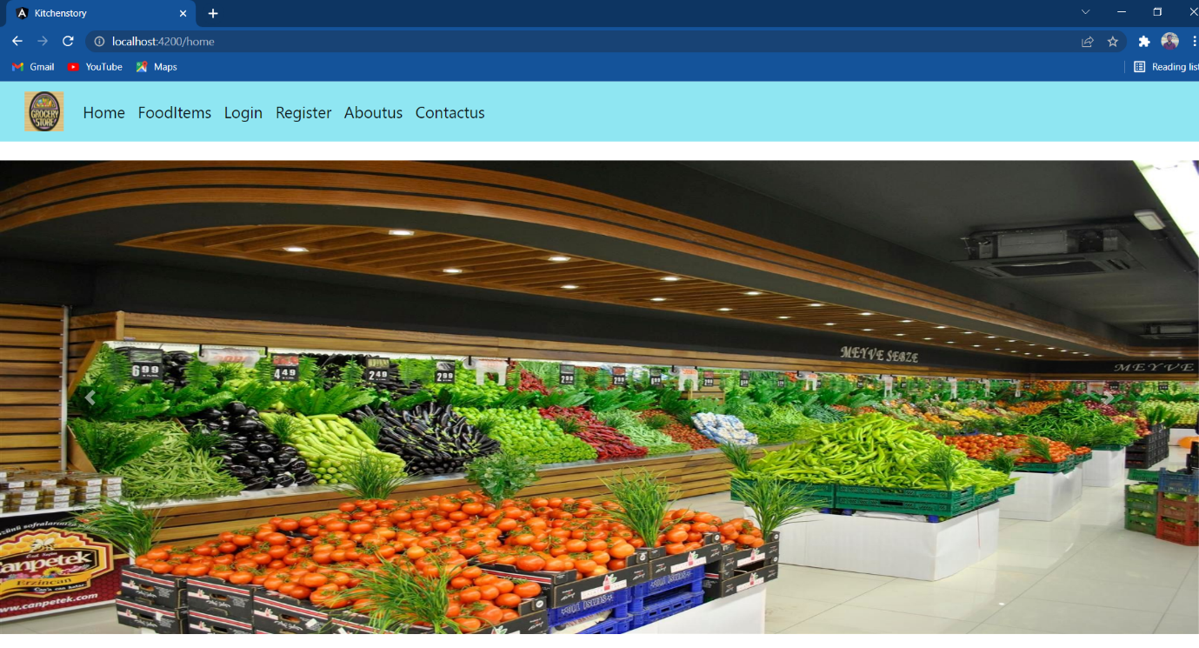

Scrolling down the home page

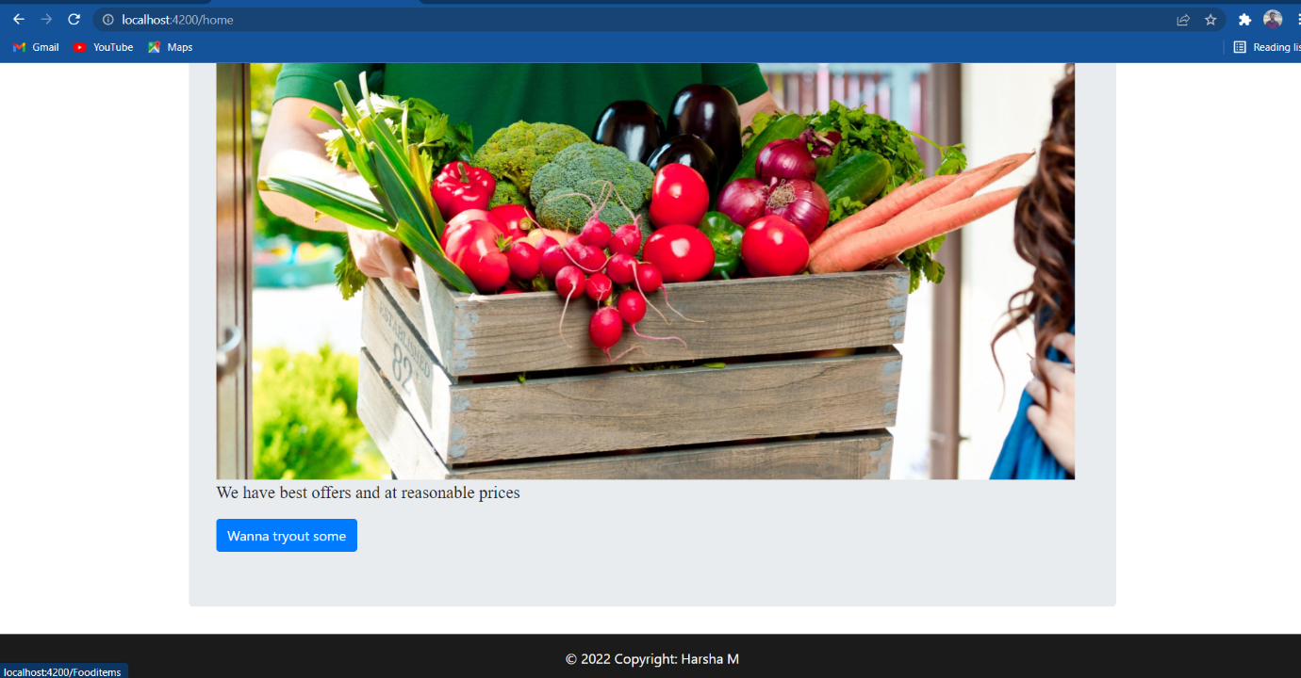

Next clicking FoodItems we can see all kind of items available

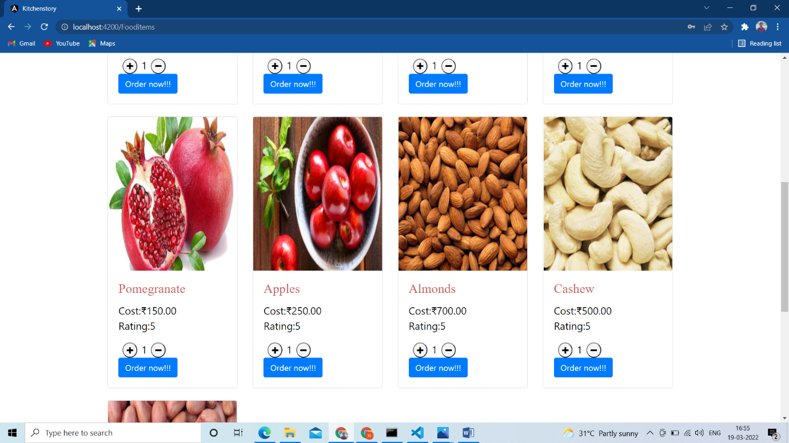

If I click order now it will ask me login first we se here alert popup

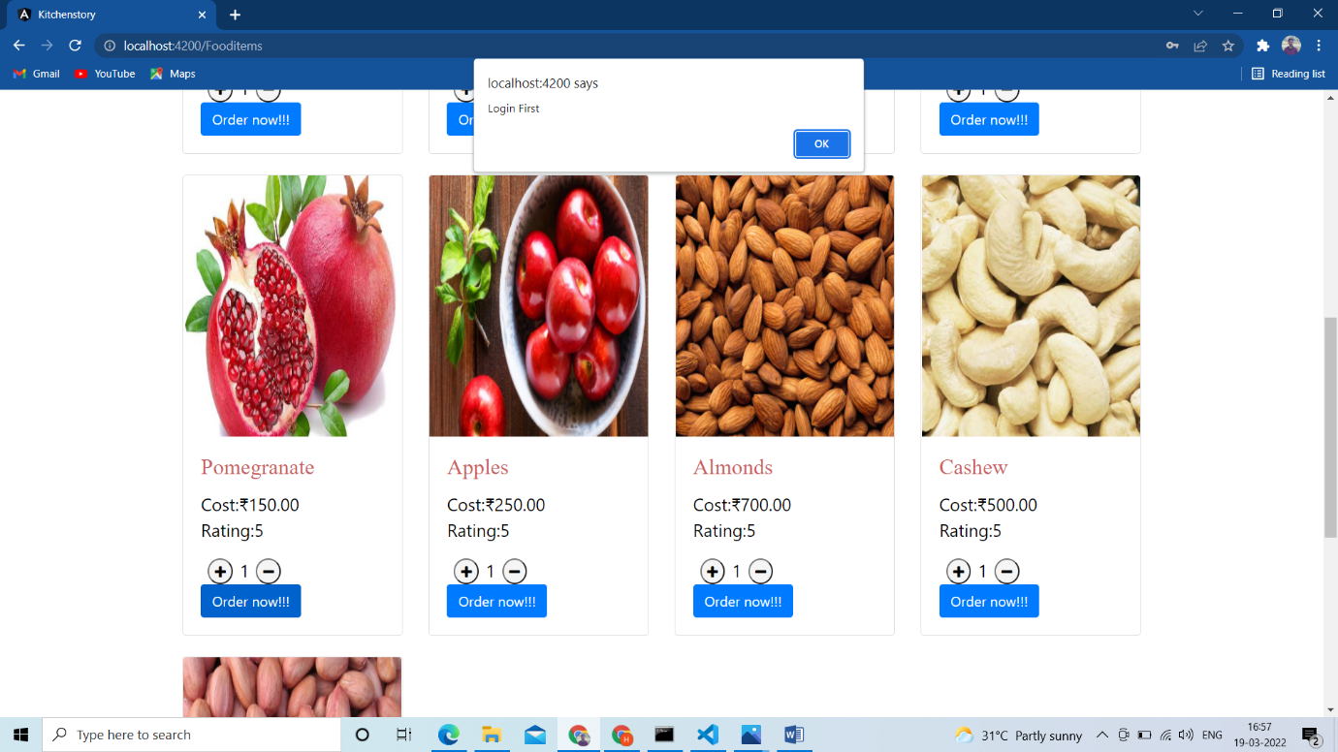

If I click ok in above alert popup it will redirect to login page we can see here

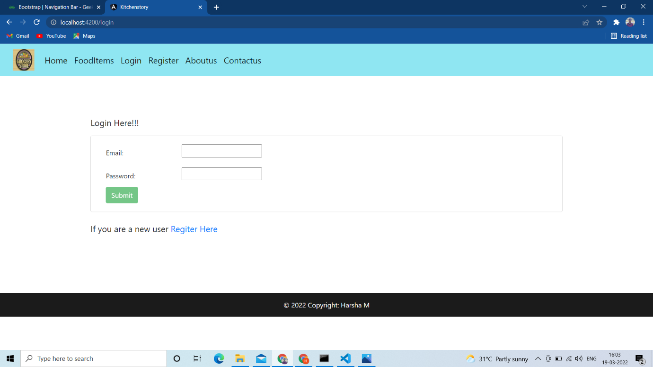

Here am not registered yet so am clicking register in nav bar so it will open this page

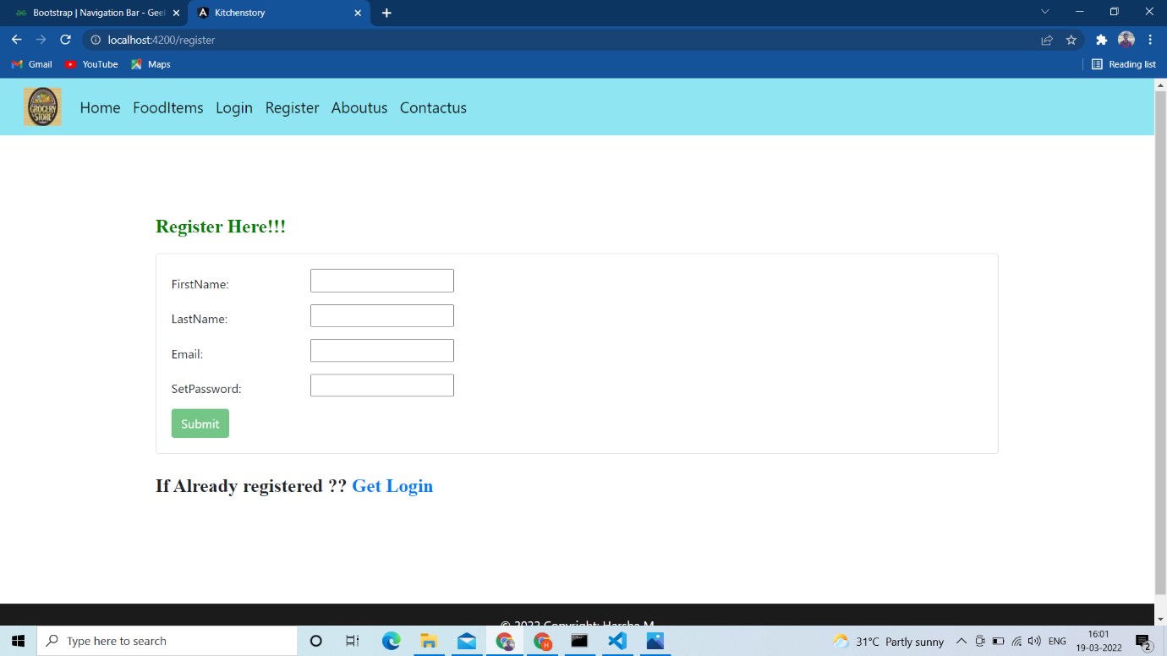

Here we can see errors because form fields we entered are less characters and submit button not accessible

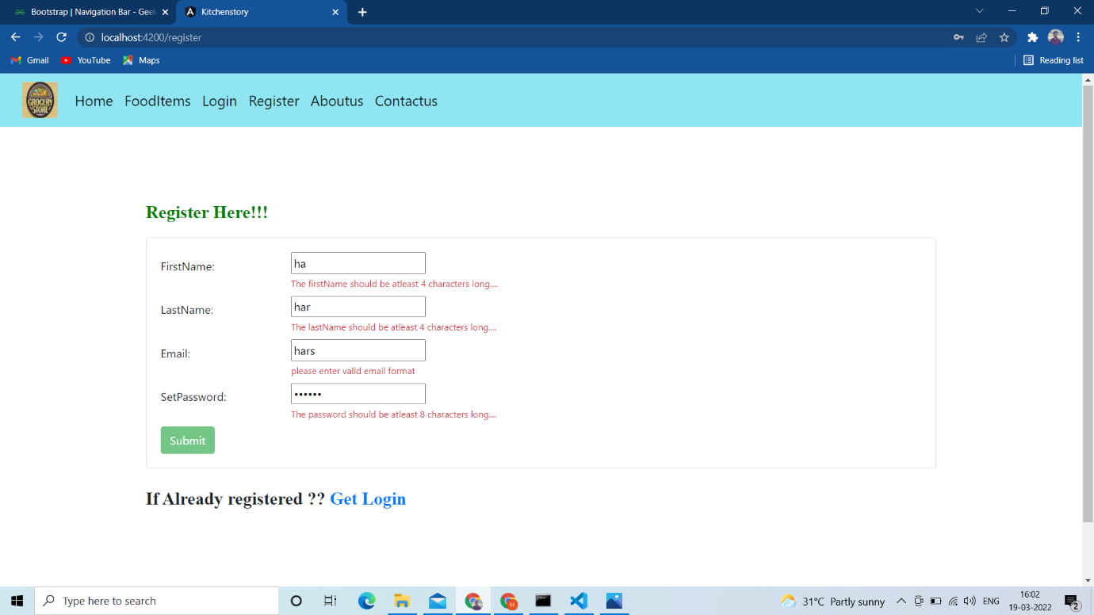

Now we can see after entering required details submit button is now completely accessible

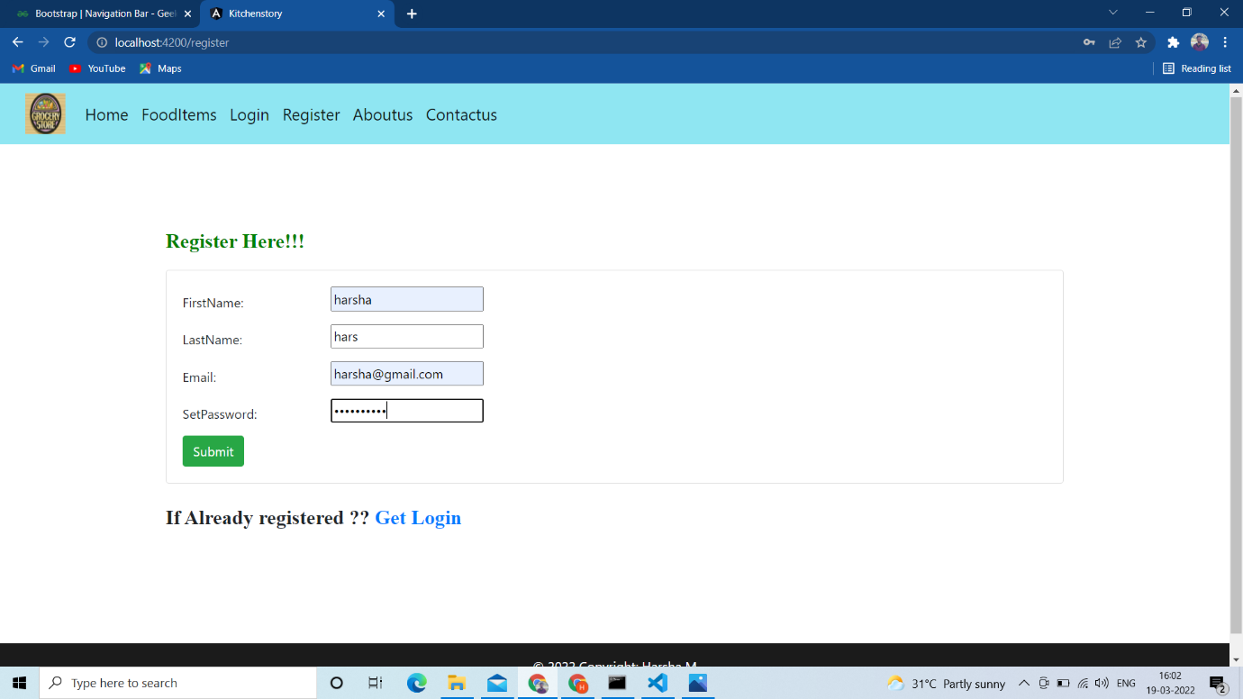

After register done while clicking submit it will redirect to login page



Trying to enter invalid details

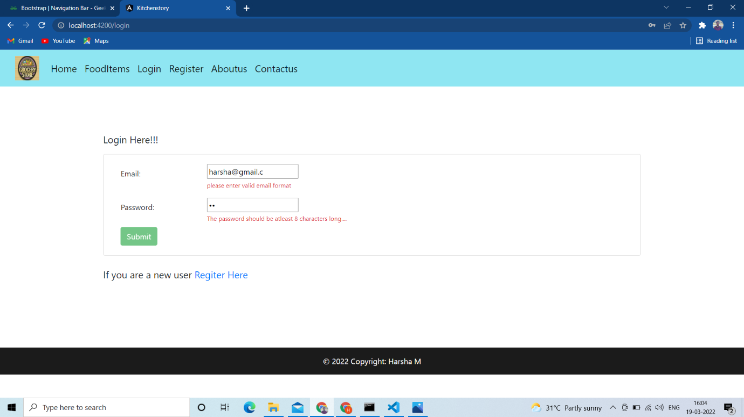

Entering valid details

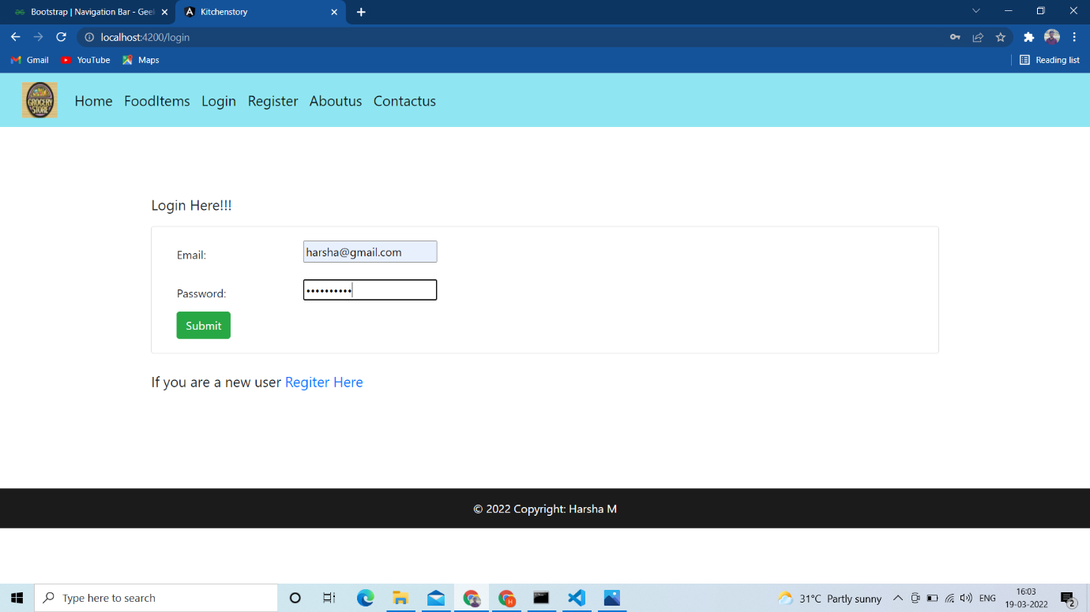

After successfull login we see three categories of items **Fruits, Cereals, Nuts**

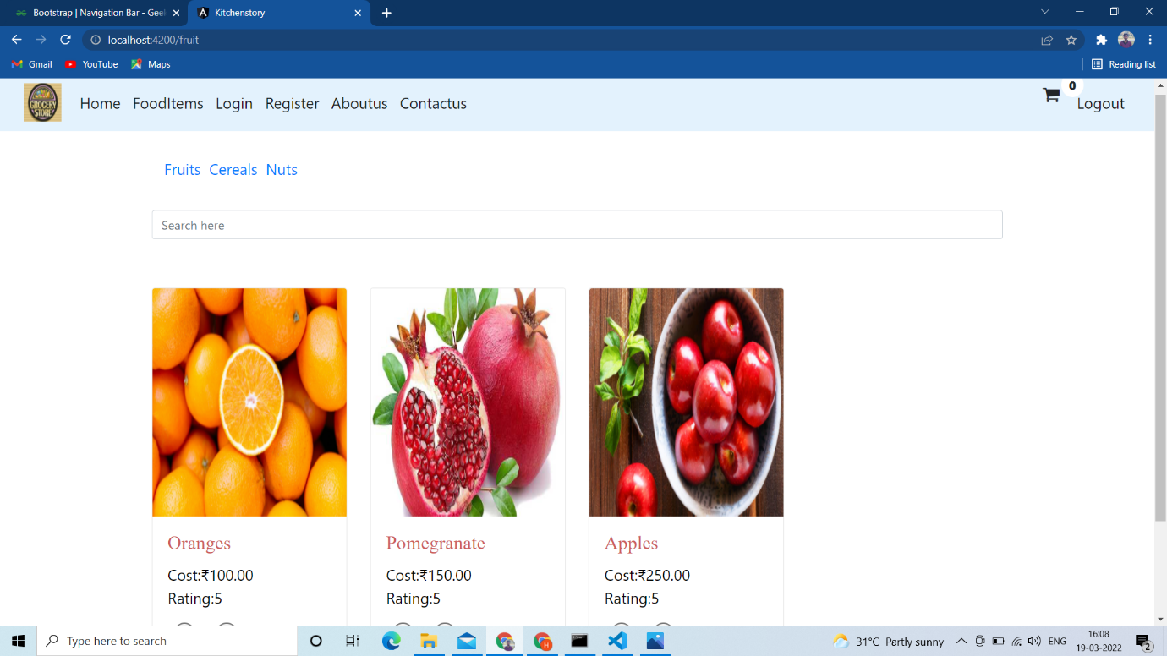

We can search Fruits

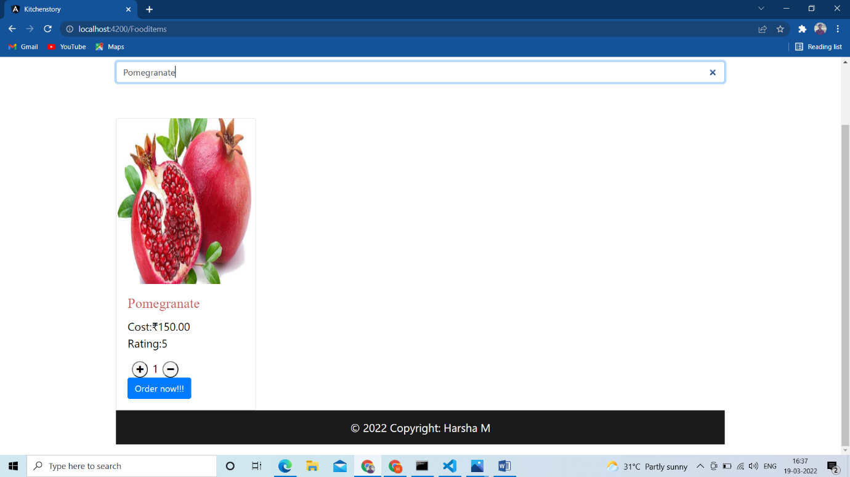

We can click cereals link this items will display and we can add to cart

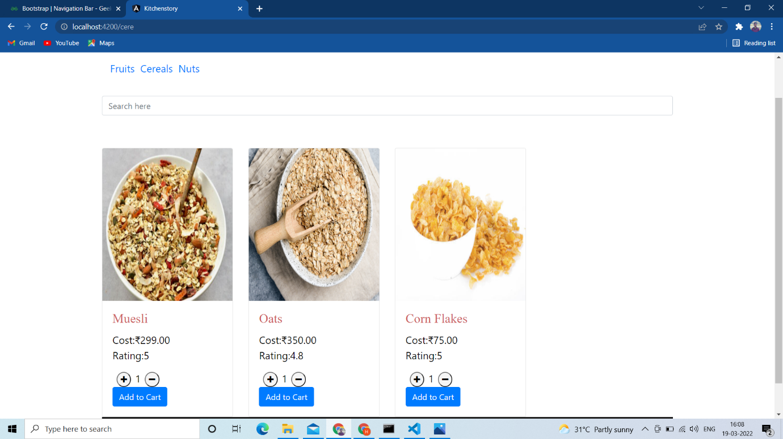

We can click Nuts link this items will display and we can add to cart

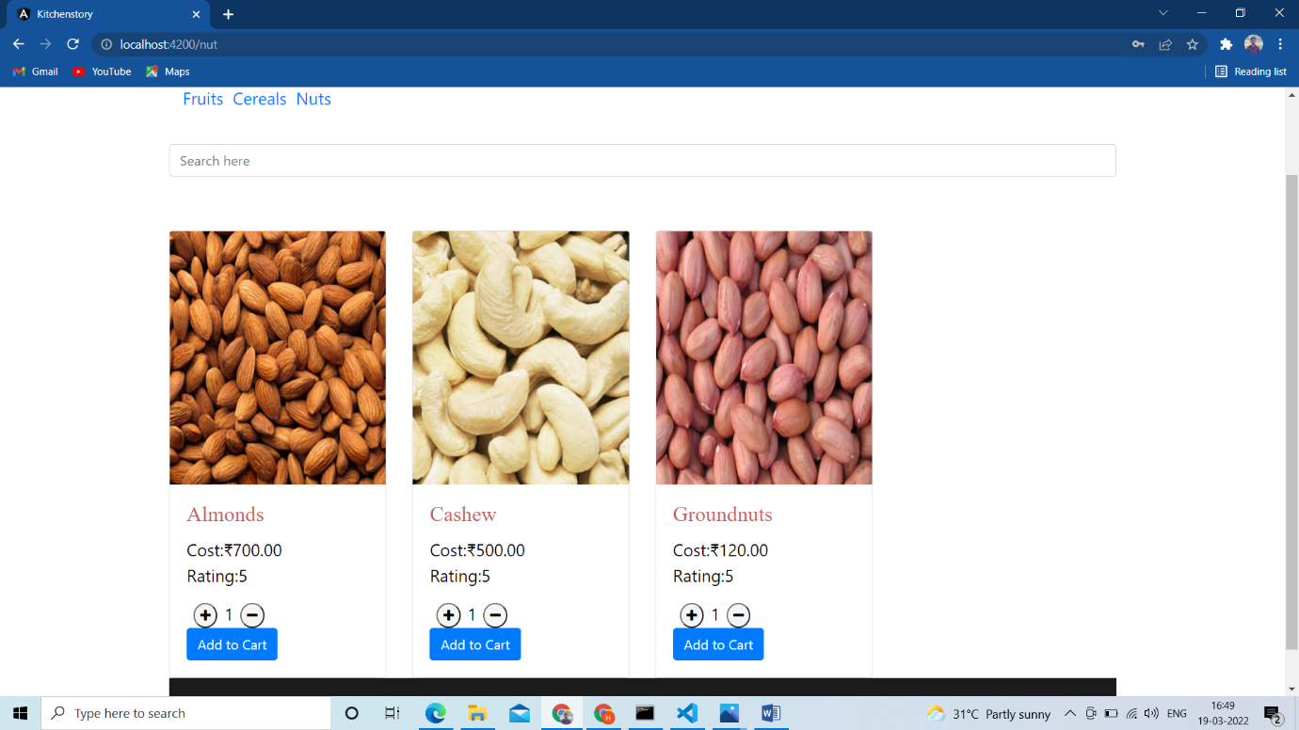

At the end of nav bar in header we can click to see added items

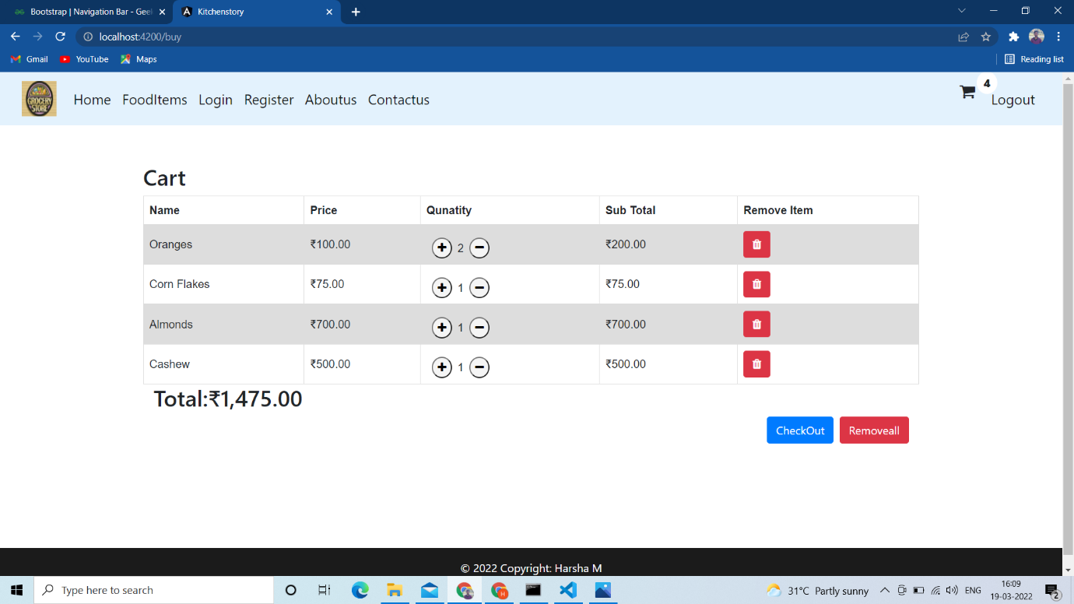

If I want to remove item then I by clicking delete symbol it will be deleted we can see here

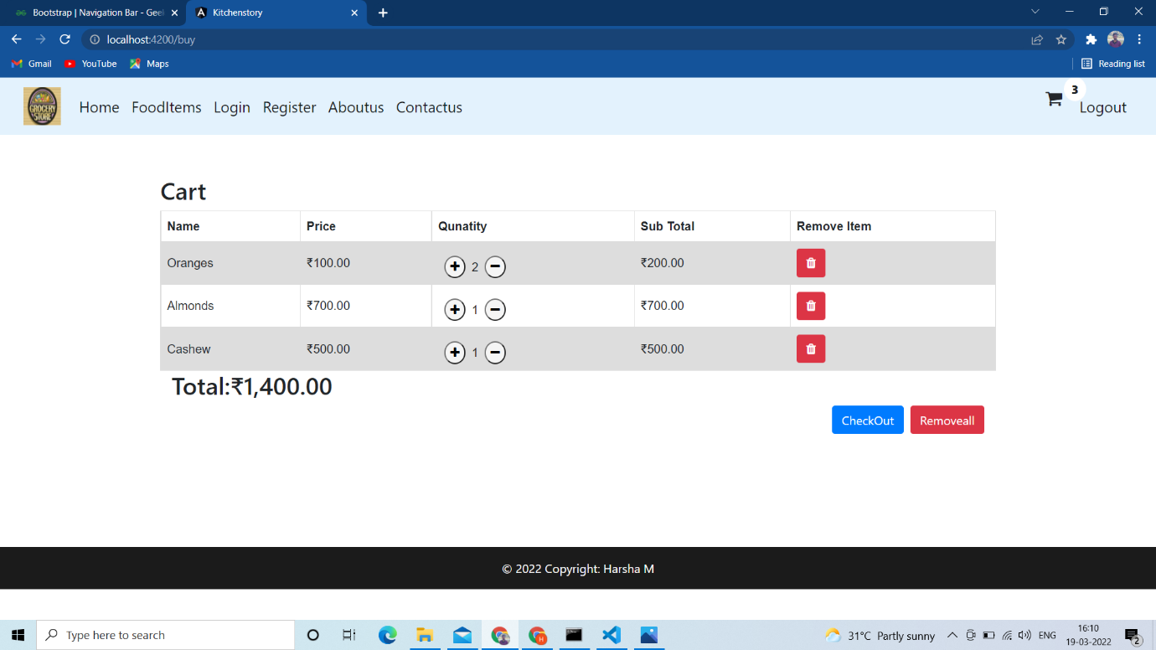

After click checkout the payment page will appear as to enter card details

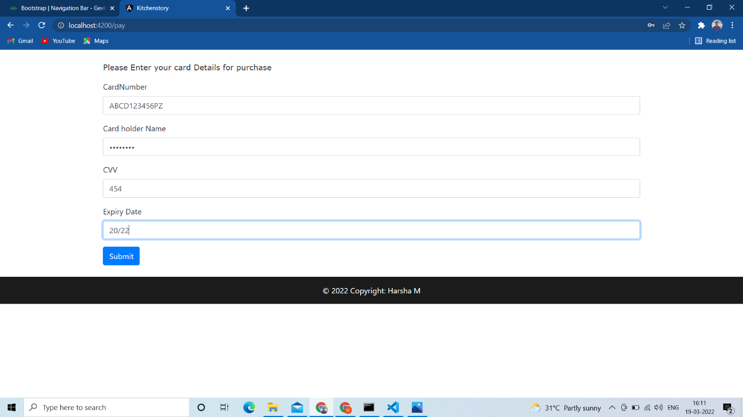

After clicking submit we can see message order placed

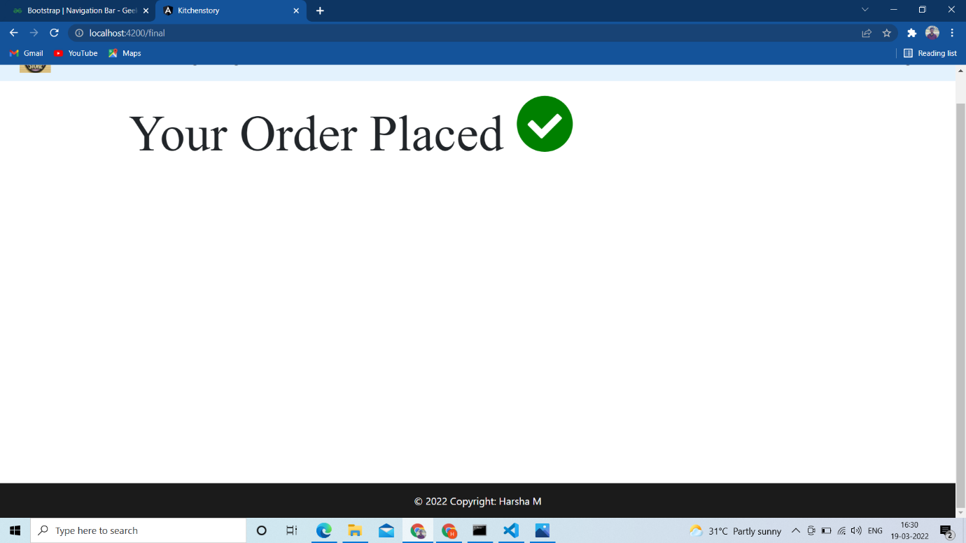

Clicking logout

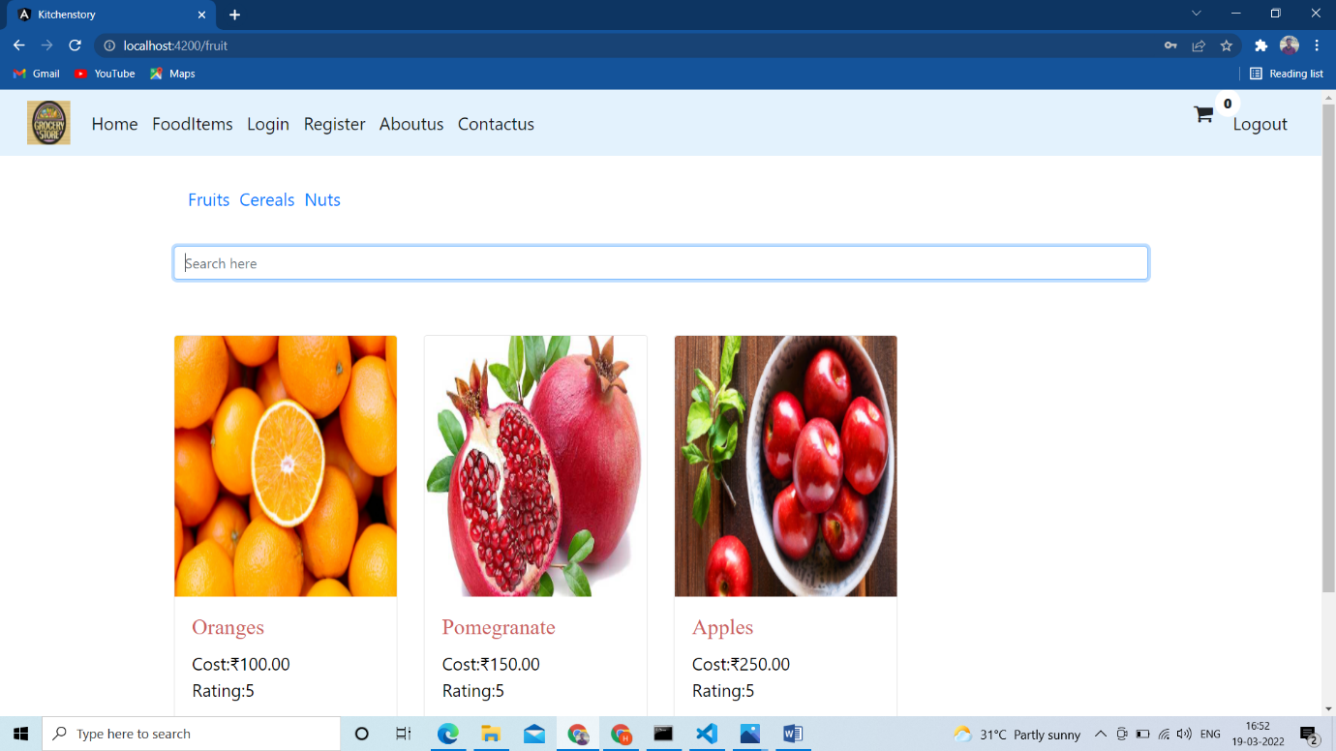

It will redirect to home page



Admin login

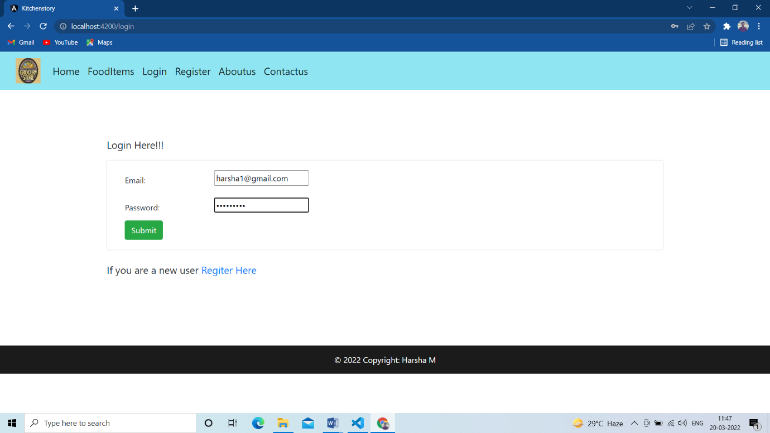

Admin works here

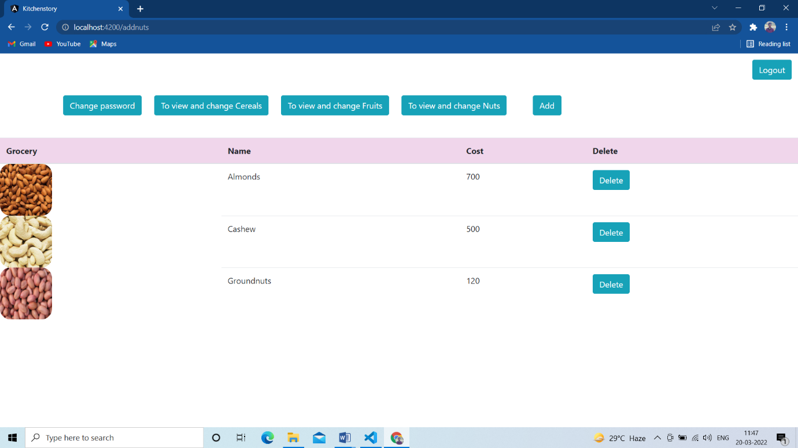

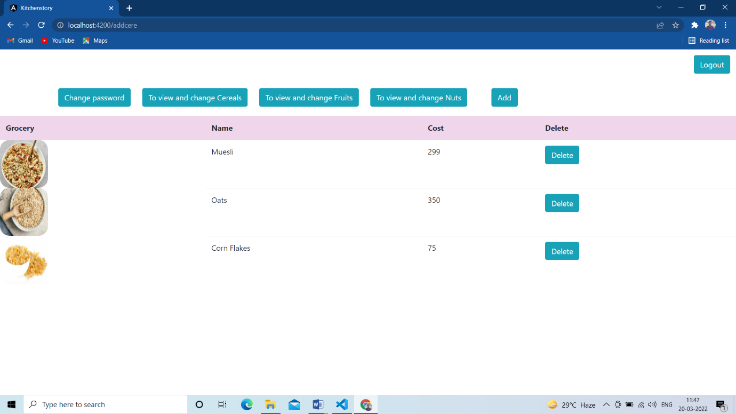



We can add new item here clicking add button

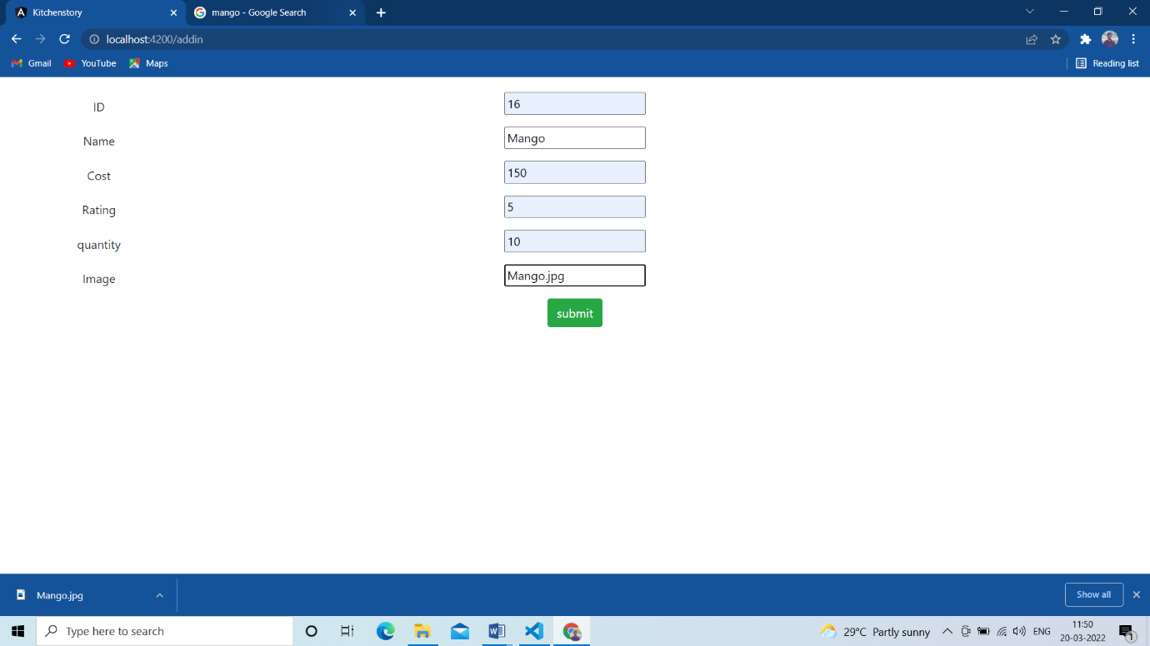

Added

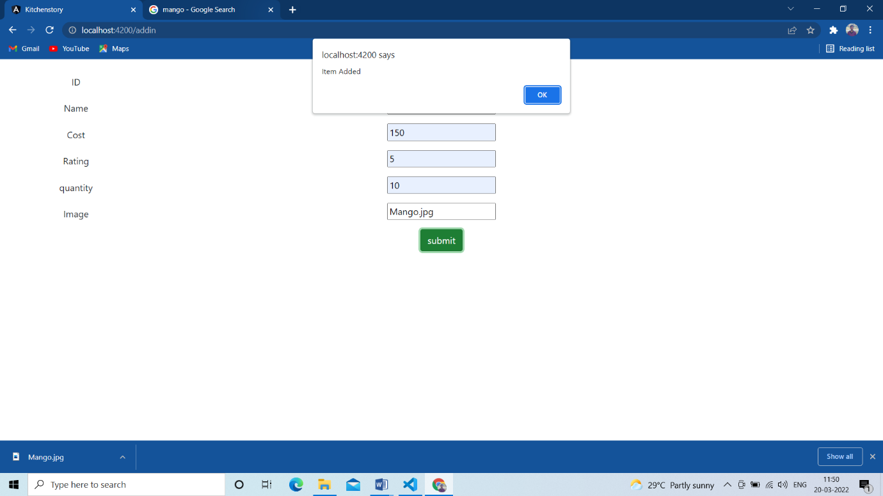

Admin can change password here

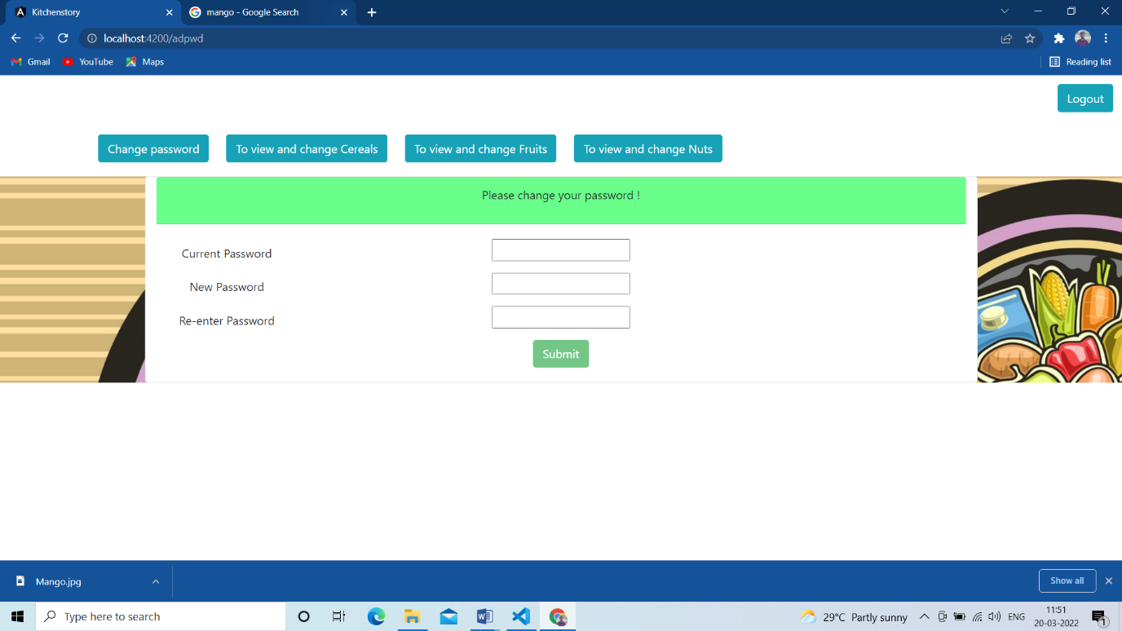

Entering new password

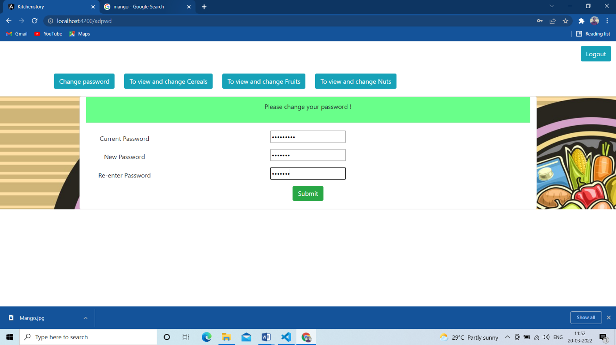

Password changed

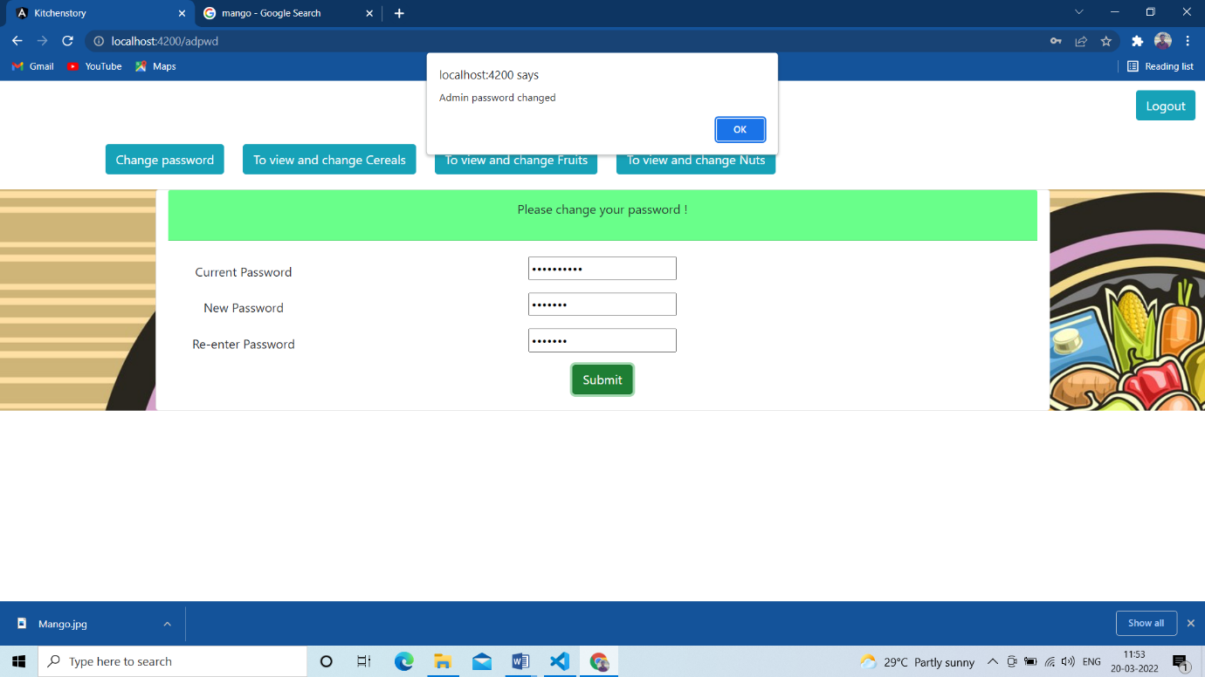



Clicking About us link

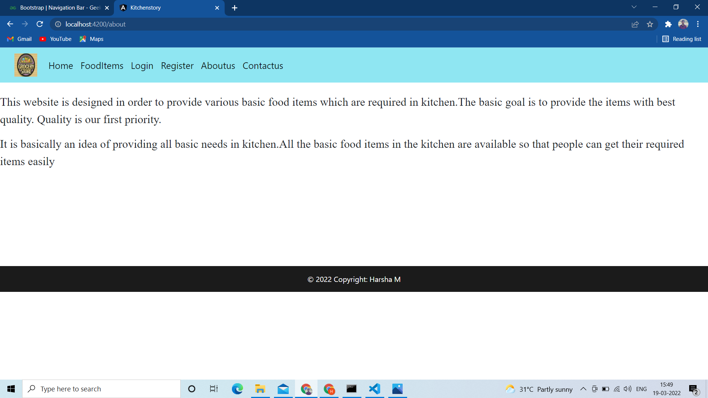

Clicking Contact us link

